INVITATION TO TENDER

for
Generator, Power & Distribution Framework 2018 – 2022
for
LONDON & QUADRANT HOUSING TRUST

PCR OPEN procedure
Our Tender Ref | LQ/GEN/002
In-Tend Ref | Head Office 00000088
Version Number | 3
Date | 07/06/2018

LIST OF CONTENTS

PART 1
SECTION A – INVITATION TO TENDER
SECTION B – INSTRUCTIONS TO TENDERERS

PART 2
SECTION C – DECLARATION
SECTION D – SELECTION
SECTION E – FORM OF TENDER

INVITATION TO TENDER

for
Generator, Power & Distribution
Framework 2018 – 2022

PART 1 OF 2

SECTION A

Invitation TO TENDER

LIST OF CONTENTS
1 | INTRODUCTION
2 | SUBMISSION OF TENDERS
3 | CONFIDENTIALITY

- INTRODUCTION

  - London & Quadrant Housing Trust (L&Q) hereby invites sealed written tenders for the provision of Generators at L&Q properties in London and the South East of England on behalf of L&Q and its subsidiaries (“Group”).

  - This Invitation to Tender (ITT) together with the other Tender Documents specifies the requirements, terms and conditions of the Tender to be complied with by Tenderers in preparing and submitting Tenders.

  - This is a competitive procedure conducted in accordance with the Open Procedure under the Public Sector Directive 2014/24/EU as implemented in the UK by the Public Contracts Regulations 2015 (as amended).

  - The requirements of the Tender Documents shall be strictly complied with and shall not be modified by Tenderers.

  - The objective of this tender is to establish a Framework Agreement with London & Quadrant Housing Trust (L&Q) and all successful tenderers.

- SUBMISSION OF TENDERS

  - Tenders are to be submitted electronically, by 18:00pm on Friday the 6th of July 2018 (Tender Submission Date) via the In-Tend Supplier portal.

  - Tenderers should clearly note that no other type of submission will be accepted and that late submission of tenders will be rejected. Submission dates could be changed at L&Q’s discretion, however the minimum timescales will be adhered to as per the Contracts Regulations 2015.

  - No unauthorised alteration or addition should be made to the Form of Tender or any other part of the Tender Documents. Tenders must not be qualified in any way and must be submitted strictly in accordance with the Tender Documents.

  - Tenders must not be accompanied by any covering letter or any statement that could be construed as rendering a Tender equivocal and/or placing it on a different footing from other Tenders.

- CONFIDENTIALITY

  - This ITT is provided in confidence, and recipients are expected to exercise appropriate levels of due care and diligence, and to act in accordance with professional standards in relation to it.

  - The contents of this ITT should not be disclosed to parties other than employees of the recipient and their professional advisers, without the prior written consent of L&Q.

SECTION B

Instructions to TENDERers

LIST OF CONTENTS
1 | DEFINITIONS
2 | BACKGROUND INFORMATION
3 | THE GOODS/SERVICE
4 | DURATION OF CONTRACTS
5 | THE FRAMEWORK AGREEMENT
6 | THE PROCEDURE
7 | TENDER DOCUMENTS
8 | SCOPE OF GOODS/SERVICES
9 | EXTENT AND FULLNESS OF TENDERS
10 | ENQUIRIES
11 | TENDER AMENDMENTS
12 | QUALIFICATIONS
13 | NOT USED
14 | SUB-CONTRACTING
15 | FORM OF TENDER AND PRICING
16 | TENDER SUBMISSIONS
17 | SIGNATORIES
18 | TENDER COSTS
19 | ANTI-FRAUD, BRIBERY AND CORRUPTION
20 | MODERN SLAVERY ACT 2015
21 | TENDER ERRORS AND VALIDITY PERIOD
22 | TENDER EVALUATION
23 | TECHNICAL/QUALITY SUBMISSION
24 | REJECTION OF TENDERS
25 | TENDER ACCEPTANCE
26 | INDICATIVE APPOINTMENT TIMETABLE
27 | DISCLAIMER
28 | COMPLIANCE AND OTHER INFORMATION

ANNEX B-1 | USING THE SUPPLIER PORTAL
ANNEX B-2 | DOCUMENT CHECKLIST

- DEFINITIONS

  - The words and expressions defined elsewhere in the Tender Documents shall apply equally here to, except where the context otherwise requires.

  - Additional definitions of words and expressions, which are not defined elsewhere, or which require re-definition for the purposes of these Instructions to Tenderers, are given below:

“Addendum” and “Addenda” | means respectively an addendum and all addenda to the Tender Documents as may be issued by L&Q during the Tender Period in accordance with the provisions of the Tender Documents.
“Call off” | means purchases from framework agreements.
“Contract” | means any one or more contracts entered into by L&Q as a result of the ITT.
“Contractor(s)” or “Service Provider(s)” | means the Tenderer(s) appointed by L&Q to perform any Contract awarded as a result of the ITT.
“Framework” or “Framework Agreement” | means an agreement with suppliers to establish terms governing contracts that may be awarded during the life of the agreement. In other words, it is a general term for agreements that set out terms and conditions for making specific purchases (call-offs).
“Group” | means L&Q and its subsidiaries.
“ITT” | means the Invitation to Tender issued by L&Q.
“L&Q” | means London & Quadrant Housing Trust.
“Rebate” | means a return of part of the original payment for some service or goods
“Mini Competition” | means making a call-off for a multi-supplier framework agreement. It is used to re-open competition between all those suppliers within a framework agreement
“Services” or “Works” | means the totality of activities to be performed under any resultant Contract.
“Site(s)” | means the Employer’s premises where activities are to be performed or Goods delivered.
“Selection” | means Stage the “Open” EU Procurement procedure and an offer to perform the supply of the Goods submitted by a Tenderer in response to Section D of the documents.
“Supplier(s)” or “Contractor(s)” or “Service Provider(s)” | means the Tenderer(s) appointed by L&Q to perform any Contract awarded or supply any Goods as a result of the ITT.
“Tender Documents” | means the whole of this document and any appendices and annexes.
“Tenderer(s)” | means any person, corporation, company, partnership or firm acting individually or jointly submitting a Tender to L&Q for the performance of the Services/Works or supply of the Goods either singly or collectively, as the context requires.
“Tender Period” | means the period from the date of the ITT until the Tender Submission Date.

- BACKGROUND INFORMATION

  - L&Q is one of the largest providers of affordable housing in the UK, managing over 70,000 homes in London and the south east of England. Although we work with over 100 local authorities, almost 80% of our homes are located in London boroughs. We have the largest development programme of any Registered Provider operating in the London area.

  - L&Q is regulated by the Homes & Communities Agency (registration number L4517), and is an exempt charity registered under the Co-operative & Community Benefit Societies Act 2014 (registration number 30441R).

2.3 L&Q Group’s activities are focused on achieving its mission statement of “creating places where people want to live” for its diverse residents by;-

- Developing and providing affordable homes for people who cannot afford to rent or buy in the open market.
- Providing a range of housing products for the intermediate market, including shared ownership, sub-market or market rent.
- Providing a range of supported housing services, both directly and through external organisations.
- Developing properties for outright sale to generate profit and cross-subsidise social housing.
- Managing student, key worker and market rent accommodation.
- Investing in community development and regeneration schemes for existing properties and those transferred from local authorities, to improve the quality of life in local neighbourhoods.

2.4 L&Q is divided into seven Neighbourhoods responsible for the delivery of housing services in distinct geographical locations as shown in the map below:

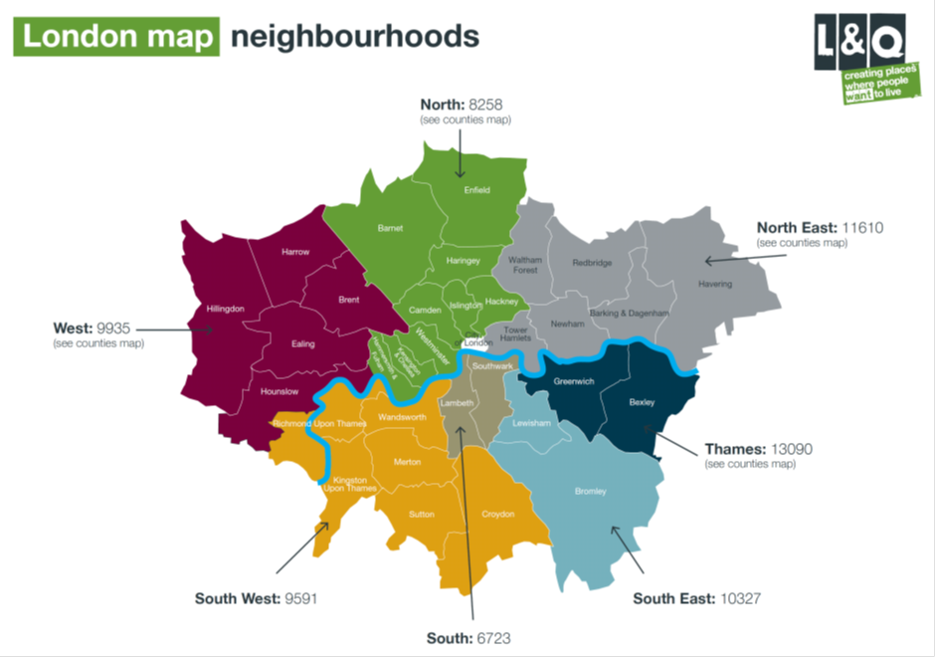
The map below shows all other areas in which L&Q operates.

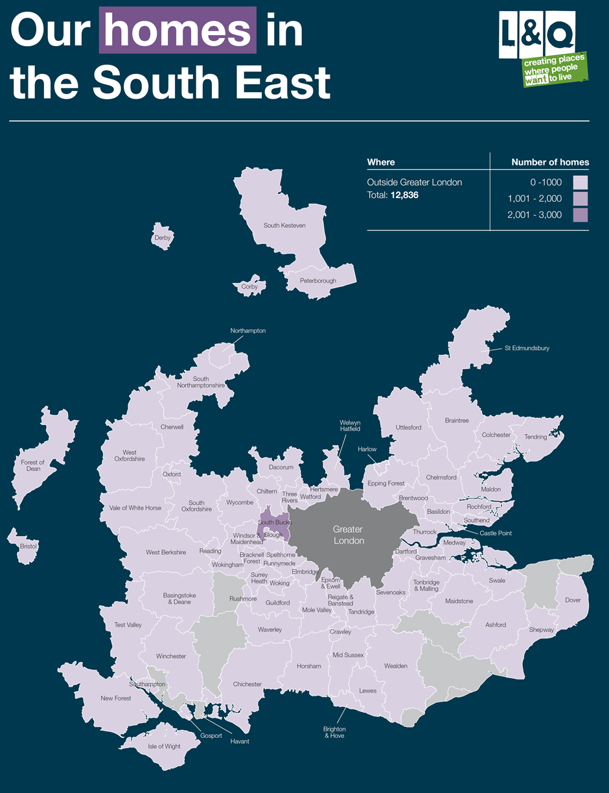

Further information about L&Q Group can be found at www.lqgroup.org.uk.

- THE GOODS/SERVICES

  - This Tender is for Generator, Power & Distribution

  - This Tender is for the inclusion on to the Generator, Power & Distribution framework. Following successful inclusion on to the framework, the successful tenderers will engage in the selection process for specific services/goods.

  - L&Q is seeking a suitably qualified and experienced Supplier/Service Provider to provide high quality Services/Goods supported by robust management and quality control processes.

  - Tenderers will need to demonstrate that they have the requisite skills, infrastructure, resources and procedures already in place to perform the Contract to the standard required by L&Q.

  - Examples of the standard expected of the Supplier/Service Provider are:
- Being able to self audit all aspects of the goods/services to ensure that consistently high levels of service are attained, including quality checks on personnel, site work and supply chain
- Providing accurate and detailed cost information to enable forward planning and budget forecasting on a quarterly basis
- DURATION OF CONTRACTS

  - The Contract with the successful supplier will each last for an initial period of FOUR years,

- THE FRAMEWORK AGREEMENT

Under the Framework Agreement L&Q and all companies within the L&Q Group (including, without limitation, Quadrant Construction Services) will have the option to call-off contracts with individual framework contractors as and when goods/services are required. In addition, other Social Housing Providers in the UK (both those that are in existence now and those that may be in existence in the future) will also be entitled to call-off contracts under the Framework Agreement. “Social Housing Provider” for this purpose means any provider of social housing and includes, without limitation, Registered Providers, Local Authorities and ALMOs. Such Social Housing Providers will only be entitled to call off under the Framework Agreement if L&Q consents.

Applicants should note that, under the Framework Agreement, L&Q shall not be under any obligation to call-off contracts with individual contractors.

Call-off procedures will include (i) direct selection and/or (ii) mini-competitions.

- THE PROCEDURE

  - The “Open” Procedure as set out in the UK by The Public Contracts Regulation 2015 will be followed for this procurement.

  - This is a SINGLE STAGE PROCESS.

  - Tenderers will be required to complete Part 2 of the ITT and ensure that all Technical Questions are answered and all documents are signed. Tenderers also must complete a pricing schedule.

  - Scoring will commence after the tendering period has closed. ITT Documents and Supplementary Documents will be scored within the indicative timetable (26) and tenderers who have been successful will be awarded a place on the framework agreement.

- TENDER DOCUMENTS

General
  - The Tender Documents consist of the following:

SECTION CONTENT
PART 1
- Invitation to Tender
- Instructions to Tenderers

PART 2
- Declaration
- Selection
- Form of Tender and Price Schedule

  - Tenderers shall be deemed to have fully satisfied themselves as to the completeness and adequacy of the Tender Documents. In connection with this, Tenderers should check the numbering of pages and advise if any are found to be missing or in duplicate.

  - The Tenderer is advised to ensure that it is fully familiar with the nature and extent of the obligations to be accepted by it if its Tender is accepted.

  - Information supplied by L&Q is given in good faith. The Tenderer must satisfy itself by its own investigation concerning the accuracy of any such information and no responsibility is accepted by L&Q for any inaccurate information obtained by the Tenderer.

  - No claim will be entertained nor liability admitted in respect of errors in tendering or consequent loss due to failures to comply with the foregoing.

  - L&Q reserves the right to change the procedure for the procurement or to terminate discussions and the delivery of information at any time before the contract is executed.
  - At its discretion, L&Q may either waive or insist on strict compliance with any requirement set out in this ITT.

  - Tenderers shall at all times:
    - Comply with the Data Protection Act 1998 (as amended from time to time) (the “DPA”);
    - Maintain the confidentiality of personal data to which it has authorised access pursuant to the ITT;
    - Indemnify L&Q and keep L&Q indemnified against loss, destruction or procuring of data contrary to the DPA by the Tenderer, its servants or agents;
    - In accordance with paragraph 12 of Part 11 of Schedule 1 to the DPA:
  - Process any personal data supplied to the Tenderer by L&Q only in accordance with L&Q’s written instructions; and
  - Comply with obligations equivalent to those imposed by a data controller by the seventh principle of Part 1 of Schedule 1 to the DPA.

  - The Tender Documents, and any document issued as supplemental to them, are and shall remain the property of L&Q, and must be returned upon demand.

  - The copyright in the Tender Documents is vested in L&Q and they may not be reproduced, copied or stored in any medium without the prior written consent of L&Q.

Confidentiality

  - The ITT, the Tender Documents and any related and supporting information provided by or on behalf of L&Q must be treated by the Tenderer as ‘Private and Confidential’.

  - The Tenderer is not to disclose or release any information relating to the ITT, the Tender Documents and any related and supporting information other than on a strictly confidential basis to those who the Tenderer needs to consult in the preparation or the submission of a bona fide Tender.

  - The Tenderer should further not disclose the fact that they have been invited to compete for the Contract, or at any time release any information concerning the Tender Documents and/or their Tender and/or any related documents and/or any negotiation and/or discussion with L&Q in this connection for publication in the press or on radio, television, screen, social media or any other medium.

  - The Tenderer warrants to L&Q that no document that it prepares as part of its Tender shall infringe any Intellectual Property Rights. The Tenderer shall retain Intellectual Property Rights in all documents that it prepares as part of its Tender submission and L&Q shall not copy or use any such documents other than for the purpose of the evaluation and consideration of Tenders and in Contractor selection.

  - L&Q reserves the right to retain all Tender documents submitted by Tenderers throughout the whole of the period that their submissions remain valid and open for acceptance.

  - Each Tenderer undertakes to indemnify L&Q and to keep L&Q indemnified against all actions, claims, demands, liabilities, proceedings, damages, costs, charges and expenses whatsoever arising out of or in connection with any breach of these provisions.

- SCOPE OF GOODS/SERVICES

  - The scope of the Goods/Services are defined within the Tender Documents.

- EXTENT AND FULLNESS OF TENDERS

  - Tenders must be submitted for the whole of the Goods/Services in accordance with the requirements of these Tender Documents and a Tender for only part of the Services will be rejected.

  - Tenderers are to familiarise themselves with the Tender Documents (including but not limited to the Preliminaries (if appropriate) and the Specification) and the Site(s) as necessary to satisfy themselves as to all the relevant aspects which could affect the pricing and the operation of the Contract. Tenderers should also note that L&Q will not consider any claim for any additional payment or reimbursement through failure to obtain all necessary information or want of knowledge.

  - Information supplied by L&Q (whether in the Tender Documents or otherwise) is provided for general guidance in the preparation of Tenders. Tenderers must satisfy themselves as to the conditions affecting the supply and cost of labour, the availability and prices of materials and all other conditions of the locality in which the Services/Works are to be carried out or Goods supplied insofar as the same might affect their Tender.

  - The Tenderer should seek all technical, financial and legal advice as part of their investigation processes and fully satisfy themselves as to their legal and other obligations not only in relation to this Invitation to Tender and the procurement process but also in respect of the Contract including but not limited to the methods and resources needed to meet L&Q’s requirements as set out in all sections of the Tender Documents.
`
  - Tenderers must satisfy themselves by their own investigations with regard to the accuracy of any information provided by L&Q, its servants or agents.

  - Tenderers are to note that L&Q shall not be held responsible or liable for any inaccurate information obtained by any Tenderer whether from a servant or agent of L&Q or otherwise and whether or not the inaccuracy is due to want of care on the part of L&Q, its servants or agents.

  - Notwithstanding the fact that the Tenderer has been invited to submit a Tender L&Q makes no representation regarding the Tenderer’s financial stability, technical competence or ability in any way to carry out the Services/Works or supply the Goods.

- ENQUIRIES

  - During the Tender Period, Tenderers may submit questions and requests for clarification or further information via the In-Tend Supplier portal.

  - Except as stated below, all questions and requests for clarification or further information and the corresponding responses, will be circulated by L&Q to all Tenderers but the identity of the Tenderer raising the query will not be disclosed.

  - When submitting a question or request for clarification or further information, Tenderers should indicate whether or not they believe the question or request for clarification or further information is commercially confidential to them and should not therefore be shared with other Tenderers. Any such question or request for clarification or further information should be marked ‘Confidential – Not To Be Circulated To Other Tenderers’.

  - If L&Q considers that, in the interests of open and fair competition, it is unable to respond to the question or request for clarification or further information on a confidential basis, it will inform the Tenderer who has submitted it. The Tenderer must as soon as practicable thereafter request that either the query be withdrawn or treated as not confidential.

- TENDER AMENDMENTS

  - In the event that amendments to the Tender Documents are required then L&Q will issue an appropriate formal Addendum to all Tenderers as early as possible, but not later than seven (7) days prior to the Tender Submission Date. Any such statement is to be acknowledged prior to the Tender Submission Date.

  - No servant or agent of L&Q has authority to vary or waive any part of the Tender Documents other than a member of L&Q’s Procurement Team who shall only do so in writing.

  - No unauthorised alteration or addition (save for the inclusion of the relevant information) should be made to the Form of Tender or any other part of the Tender Documents.

  - Tenders must not be qualified in any way and must be submitted strictly in accordance with the Tender Documents, including these Instructions to Tenderers.

  - Tenders must not be accompanied by any covering letter or any statement that could be construed as rendering a Tender equivocal and/or placing it on a different footing from other Tenders.

  - Additional content and appendices containing materials and documentation to that requested such as brochures, marketing literature, case studies or project histories, unless specifically requested, will not be considered as part of the Tender and will be disregarded in the assessment and evaluation of Tenders.

- QUALIFICATIONS

  - No qualification of or amendment to the Tender Documents shall be made other than in accordance with the procedure detailed above. Any other qualification or amendment made by a Tenderer will be ignored and it will be assumed that the original text stands.

- NOT USED

- SUB-CONTRACTING

  - The Tenderer shall not sub-contract or outsource any of these services.

- NOT USED

- TENDER SUBMISSIONS

  - Tenders are to be submitted electronically, by 18:00pm on Friday the 6th of July 2018 via the In-Tend Supplier portal. Tenderers should clearly note that no other type of submission will be accepted and that late tenders will be rejected.

  - Tenderers should only submit Part 2 of the Tender documents together with any supporting documentation required.

  - Part 1 of the Tender documents is for Tenderer information only and therefore does not need to be returned by Tenderers.

  - The Tenderer’s attention is specifically drawn to the deadline for submission of Tenders via the In-Tend Supplier portal. When uploading documents, please ensure sufficient time is allowed for uploading documents and submission. Late submissions will not be considered.

  - Further information on the use of the Supplier Portal can be found at Annex B-1.

  - The Tenderer is fully responsible for the proper submission of any Tender and/or supporting documentation by the time and date stated whether the submission is undertaken by the Tenderer, anyone representing the Tenderer or an agent on behalf of the Tenderer.

  - The Tenderer is to note that their Tender is to be submitted in accordance with the provisions of Section A. No other type of submission will be accepted.

  - No late submissions can be accepted.

  - L&Q may, at its own discretion, extend the Tender Submission Date stated in the Invitation to Tender or as notified in writing to the Tenderers by L&Q.

  - L&Q will not otherwise consider requests for any extension of the Tender Submission Date.

  - Tender submissions which are delivered by fax or email will not be considered by L&Q and will be returned to the Tenderer.

  - The Tender submission and all supporting documentation are to be completed in the English language. All financial sums and amounts must be in pounds sterling.

- SIGNATORIES

  - All documents requiring a signature must be signed:
  - where the Tenderer is an individual, by that named individual;
  - where the Tenderer is a Partnership, by a Partner on behalf of all the Partners;
  - where the Tenderer is a Company within the meaning of the Companies Act 2006, by a Director or the Company Secretary, such persons being duly authorised for that purpose.

  - All Forms and Certificates which require a signature must be physically signed, scanned and submitted as a PDF copy. No electronic signatures will be accepted.

- TENDER COSTS

  - It is the responsibility of the Tenderer to obtain for themself at their own expense all information necessary for the preparation of its Tender.

  - All costs, expenses and disbursements incurred by the Tenderer in the preparation and submission of their Tender; participation in any discussions, interviews and the like; and, in the case of acceptance of a Tender by L&Q, any clarification and discussions are to be borne in full by the Tenderer.

  - Whilst every effort has been made to give an accurate description of requirements set out in this ITT, Tenderers should form their own conclusion about the methods and resources needed to meet the requirements. L&Q cannot accept responsibility for any costs incurred during the participation in this procurement exercise including any costs relating to the preparation of the Tender.

  - L&Q shall further not be liable for any loss suffered by the Tenderer should its Tender not be accepted by L&Q, or in the event that no Contract is placed as a result of this Tender.

  - No subsequent claim on the grounds of insufficient or inaccurate information or any failure to have ascertained at the Tender stage the full nature of the Goods/Services and, where appropriate, the need to work closely with L&Q, its residents and their representatives, and other contractors will be entertained.

- ANTI-FRAUD, BRIBERY AND CORRUPTION

  - L&Q has an Anti-Fraud, Bribery and Corruption policy.

  - All Tenderers are required to complete the Anti-Fraud Bribery and Corruption Declaration attached as Part 2, Annex D-2 which confirms no collusion has occurred between Tenderers, and no form of bribery or inducement has been offered to any employee or person involved in awarding the Contract.

  - If a Tenderer fails to sign and return this as part of its submission the Tender may be deemed to be non-compliant.

- MODERN SLAVERY ACT 2015

  - In line with the Modern Slavery Act 2015, L&Q is committed measures to work towards eradicating modern slavery from its supply chain.

  - All Tenderers are required to complete the Modern Slavery Declaration attached as Annex D-3 in Part 2, which confirms that they have not been involved in slavery or human trafficking of any kind;

  - If a Tenderer fails to sign and return this as part of its submission the Tender may be deemed non-compliant.

- TENDER ERRORS AND VALIDITY PERIOD

  - If, upon examining a Tender, L&Q detects an error in price entry or computation, the Tenderer shall be given details of the error(s) and afforded an opportunity to correct such error(s) or withdraw the Tender.

  - Unless otherwise stated, Tenders are to remain valid and open for acceptance by L&Q for a minimum period of 20 calendar weeks from the Tender Submission Date and thereafter unless formally notified in writing to L&Q.

- TENDER EVALUATION

Stage 1 - Selection
Supplier/Contractor/Service Provider selection will be undertaken on the basis of the most economically advantageous offer, with both quality and price forming part of the tender evaluation process.

Stage 2 – The Framework Process
Following successful completion of stages 1 & 2, the successful tenderers will be included on to the initial 4 year framework. Thereafter, those included on the framework will be engaged in the selection process for specific services.

- TECHNICAL/QUALITY SUBMISSION

  - The Tenderer is to submit with this Tender, full responses to Part 2 having full regard both to content and any stipulations regarding format and length.

- REJECTION OF TENDERS

  - L&Q shall reject a Tender without prejudice to any other civil remedies available to L&Q or any criminal liability the Tenderer may attract, if the Tenderer:
  - fixes or adjusts the price shown in its Tender by or in accordance with any agreement with any other person, group or by reference to any other Tender submission;
or
  - communicates to any person other than L&Q the amount or approximate amount of the prices shown in its Tender except where such communication is made in confidence in order to obtain quotations necessary for Insurance, Guarantee Undertaking or other matters referred to in these Tender Documents;
or
  - enters into any agreement or arrangement with any other person that such other person shall refrain from submitting a Tender or shall limit, restrict or amend the prices to be shown by any other Tenderer in its Tender submission;
or
  - offers or agrees to pay or give or does pay or give any sum of money, inducement or valuable consideration whether directly or indirectly to any individual or group for doing or having done or for causing or having caused to be done any act of omission in relation to any other Tenderers or any other person's proposed Tender;
or
  - shall have offered, given or agreed to give any person, any gift or consideration of any kind as an inducement or reward for doing or forbearing to show favour or disfavour to any person in relation to the Contract or any other contract with the Group, or if the like acts shall have been done by any person employed by the Tenderer or acting on its behalf (whether with or without the Tenderer’s knowledge) or if, in relation to any contract with the Group, the Tenderer or any person employed by that Tenderer or acting for them shall have committed an offence under the Bribery Act 2010.

  - L&Q may (but shall not be obliged) at its discretion but always acting proportionately and in accordance with the law deselect a Tenderer or a Contractor if:
- the price is unaffordable;
or
- the Tender is incomplete, misleading or inaccurate;
or
- the Tender is not submitted as stated and required by L&Q which therefore makes a Tender ‘not compliant’ for evaluation and full consideration by L&Q. The Tenderer is to note that this applies to both technical and price elements;
or
- the Tenderer seeks to negotiate;
or
- the Tenderer makes material changes to, or (in L&Q’s opinion) a material change takes place in respect of Tender unless substantial justification can be provided to the satisfaction of L&Q.

  - L&Q further reserves the right to reject or disqualify a Tenderer where there is a change in identity, control, financial standing or other factors impacting on the selection and/or evaluation process affecting the Tender.

  - L&Q reserves the right to instruct other contractors for provision of the Goods/Services where a conflict of interest might prevent those appointed from acting for L&Q.

- TENDER ACCEPTANCE

  - Forthwith upon the written acceptance of a Tender or part thereof by L&Q, the Tenderer shall execute, as a Framework Agreement.

  - If the Tenderer shall fail to comply with any the provisions of 23.1 above, L&Q may (without prejudice to any other right or remedy available to it), terminate the Contract by notice to the Tenderer having immediate effect.

- INDICATIVE APPOINTMENT TIMETABLE

The following timetable indicates the key timescales for this procurement exercise:

ACTIVITY | DATE
Issue of Invitation to Tender (ITT) | Wednesday the 6th of June 2018
Deadline for ITT Submissions | Friday the 6th of July 2018
Evaluation and internal authorisation | Friday the 6th of July 2018
Contract Services Commencement Date | On Going

This timetable is provided for information purposes only and may be subject to change without notice. The aggregate time scales for completion of the two stages adhere to the time-scales under the 2015 Public Contracts Regulations for Open OJEU Tenders.

- DISCLAIMER

  - The materials in the Tender Documents reflect L&Q’s current view of the Goods/Services. L&Q reserves, at its discretion, the right to amend such materials as it considers appropriate from time to time. Whilst the information in the Tender Documents has been prepared in good faith, it does not purport to be comprehensive or to have been independently verified. This ITT is issued on the basis that:
- neither L&Q nor any of its advisers accept any liability, responsibility or duty of care to anyone other than L&Q for its adequacy, accuracy, completeness or for anything said or done in relation to the procurement to which this ITT relates;
- neither L&Q nor any of its professional advisers make any (express or implied) representation or warranty either about the information contained in this ITT or on which it is based, or about any written or oral information that may be made available to any Tenderer, funder, other interested person or their professional advisers;
- nothing contained in this ITT constitutes an inducement or incentive in any way to persuade an interested person to pursue its interest, make a Tender or enter into the Contract or any other related agreement;
- this ITT is not intended to provide a basis for any investment decision and should not be considered as a recommendation by L&Q or any of its advisers;
- neither this ITT nor any information supplied by L&Q or any of its advisers should be relied on as a promise or representation as to the future; and
- this ITT is neither an offer capable of acceptance nor is it intended to create a binding contract nor is it capable of creating such a contract by any subsequent actions.

  - L&Q does not bind itself to accept the lowest or any Tender submitted and reserves exclusively to itself the right at its absolute discretion to accept or not to accept any Tender submitted.

- COMPLIANCE AND OTHER INFORMATION

  - Submissions will be checked initially for compliance with the ITT and for completeness. Submissions that are not substantially complete and/or compliant with this ITT may be rejected. Failure to return required information or signed certificates may result in a rejection. During the evaluation period, L&Q reserve the right to call for further information or clarification from the Tenderers to assist in its consideration of their submissions.

  - The Tenderer is to complete and return with his Tender, the Declaration of Compliance enclosed at Annex D-1 in Part 2.

  - For information, a “Checklist of Information Required” is given in Annex B-2.

ANNEX B-1 USING THE IN-TEND E-PROCUREMENT SYSTEM
ITTs are to be submitted utilising L&Q’s e-Tendering Supplier portal In-Tend https://in-tendhost.co.uk/lqgroup/aspx/Home.

No other means of submission will be accepted.

For guidance on using In-Tend, please visit the Support Pages at https://in-tendhost.co.uk/lqgroup/aspx/Help.

In preparing and submitting their SQs, Suppliers are to note the following Acceptable file types:
      - Adobe PDF
      - Microsoft Office (version 2010 or earlier) i.e. Word, Excel, PowerPoint etc
      - Microsoft Project (version 2007 or earlier)
      - Picture files i.e. jpeg, gif, bitmap, png etc
      - Zip Files – before submitting your Tender please check these have successfully uploaded to the Supplier Portal. This should be done by attempting to open the Zip file upload as shown within the portal

If a Supplier wishes to submit any other file type, they must ensure that it is acceptable to L&Q before uploading their ITT, by raising a query via In-Tend.

L&Q will not be able to accept documents larger than A3.

All Forms and Certificates that require a signature must be physically signed, scanned and submitted as a PDF copy. Electronic signatures will not be accepted.

Submissions must include all documentation and information as stated in the ITT.

Document files must be labelled using the following format:

Question Number_Description of File
i.e.: E4_Details of Potential Staff

When uploading documents Suppliers should use the appropriate placeholder where this has been requested.

The recommended maximum individual file size per upload is 20 megabytes.

Suppliers are strongly advised to allow adequate time for uploading their ITT in advance of the deadline to avoid any last minute problems.

For questions on how to use the web site please contact the In-Tend Support team at support@in-tend.com or on 0845 557 8079 / +44 (0) 114 407 0065 alternatively please contact the L&Q Procurement Team at procurement@lqgroup.org.uk.

ANNEX B-2
CHECKLIST OF INFORMATION REQUIRED
Before submitting your Tender please ensure you have answered all relevant questions appropriate to your application, completed all sections in Part 2 in full and signed all Declarations, Form of Tender etc. as necessary.

The following list has been prepared to enable you to check requirements and ensure the relevant documentation is returned.

Notwithstanding the contents of the Checklist, it is the full responsibility of the Tenderer to ensure that all relevant documentation is returned as part of their completed Tender submission.

SECTION | DOCUMENT | DESCRIPTION | REQUIRED
PART 2
C | Appendix C-2 | Financial Analysis Form | Yes
D | Main Body | Technical/Quality Questions | Yes
D | Annex D-1 | Declaration of Compliance | Yes
D | Annex D-2 | Anti-Fraud, Bribery and Corruption Declaration | Yes
D | Annex D-3 | Slavery/Human Trafficking Declaration | Yes
E | Annex E-1 | Form of Tender | Yes

Separate Documents
 | Spreadsheet | Generator, Power and Distribution Price Schedule | Yes

END

